The Body-Worn Camera Experience
Video Overview of the Phoenix Smart Policing Initiative (SPI)

Body worn cameras have captured the attention of law enforcement in recent months. Policy and decision makers are looking for evidence of their utility and effectiveness. CNA and Arizona State University developed an informative video based on the Phoenix Police Department’s recent experiences with body-worn cameras, providing some experiential information about implementation and impact of this new technology.

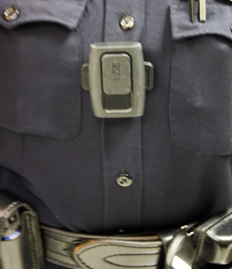
The Phoenix Smart Policing Initiative is developing, implementing, and evaluating an innovative approach using body worn cameras for increasing police accountability and enhancing the effectiveness of the police response to domestic violence. The Phoenix SPI project consists of purchasing and deploying on-officer video cameras to record the interactions between community members (e.g., the public, suspects, and victims) and officers. The Phoenix Police Department has partnered with Arizona State University (ASU) to evaluate the effectiveness of this technology. The department is exploring the evidentiary benefits of the video recordings (as a means of documenting statements, observations, and behaviors), as well as the technology’s potential for preventing and deterring unprofessional, illegal, and inappropriate behaviors by both the police and the public. To date, 56 officers in the Maryvale Precinct in West Phoenix are wearing cameras over the course of three daily shifts. The cameras are the size of a pager, and are worn on the chest area of an officer’s uniform. Recordings are uploaded to a video server at the end of each shift with a police report number and the type of call entered for each report.

In early September 2013, ASU School of Criminology and Criminal Justice Professor Michael White interviewed Michael Kurtenbach, Commander of the Phoenix Police Department's Maryvale Precinct and Charles Katz, Director of the ASU Center for Violence Prevention and Community Safety, about the Phoenix SPI project.

A video interview discussing the lessons learned from the selection, implementation, and evaluation of the body-worn cameras can be viewed online at: http://ccj.asu.edu/news-events/news/spi-phoenix-police-department-body-worn-camera-project.

Suggested segments to view include:
- Cameras and police transparency
- Cameras effect on citizen behavior
- Cameras effect on police behavior
- What other agencies should know

